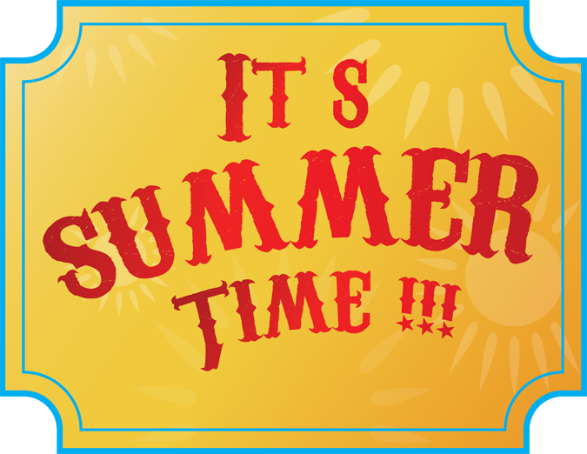

**Dear Parents and Children,**

**Welcome back to school! We hope you had a fantastic Spring holiday! We are so excited to be back and see the J.K. class!**

**Please watch the notice board for any events coming up this term such as Mother’s Day, Father’s Day, Graduation and many other fun events.**

**The children are very settled and as you have seen very comfortable with you in the room. You’re welcome to read, do crafts, cook or just play!**

**Thank you for all your support last term – what an amazing turn out we had for Sports Day. The children had so much fun! We all had a 10min dance party to celebrate the accomplishment!**

**We wish you a fantastic term ahead and please feel free to come and chat with myself or Mrs. Jeannette anytime.**

**Miss Claire Marie and Mrs. Jeannette**

’

**Topic!**

**The Lighthouse Keepers Lunch**

**J.K. adore this ‘award winning’ story.**

**We aim to bring this book to life in the classroom. Please see our topic map to get a picture of what your child will be doing in class ☺**

J.K

Please remember to bring a hat, plenty water, a change of clothes and a healthy snack& lunch!

**Drop Off: 8.10-8.30**

**Pick Up: 12pm or 3pm**

2017

Summer Term